Verification Plan
8-bit Arithmetic Logic Unit (ALU)
ALU RTL (ALU.sv) verified against UVM-style SystemVerilog testbench
Prepared for: ADI Digital Design Verification
Prepared by: Youssef Bassem Lamey

ALU Block Diagram and Specification
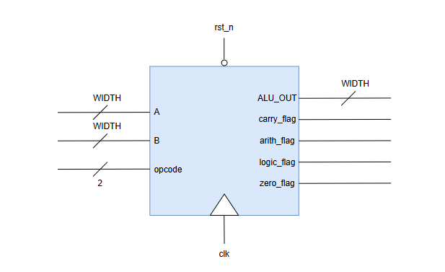
Figure 1: ALU port diagram
- 8-bit signed Arithmetic Logic Unit (WIDTH = 8).
- Reset signal rst_n is asynchronous, active low.
- Two WIDTH-bit signed operands, A and B.
- 2-bit opcode selects the operation: ADD, SUB, AND, XOR.
- ALU_OUT is a WIDTH-bit registered result, updated on the positive edge of clk.
- carry_flag is active high for ADD/SUB whenever the operation produces a carry-out / borrow beyond the MSB; registered.
- arith_flag is active high whenever opcode is ADD or SUB; registered.
- logic_flag is active high whenever opcode is AND or XOR; registered.
- zero_flag is active high whenever ALU_OUT == 0; combinationally derived from the registered ALU_OUT.
- On reset (rst_n = 0), ALU_OUT, carry_flag, arith_flag, and logic_flag are all forced to 0.
- Unlike a priority-encoded control scheme, exactly one operation is selected per cycle directly by opcode — there is no signal-priority arbitration in this design.

Signals
- RST (rst_n) -> Asynchronous, active low; all registered output signals (ALU_OUT, carry_flag, arith_flag, logic_flag) must be forced to zero immediately, independent of clk.
- A, B -> WIDTH-bit signed operands; driven with valid constrained-random or corner values (see Sequences).
- opcode -> 2-bit operation select, sampled at posedge clk:
- ADD -> ALU_OUT <= A + B; carry_flag <= carry-out of the addition.
- SUB -> ALU_OUT <= A - B; carry_flag <= borrow-out of the subtraction.
- AND -> ALU_OUT <= A & B; carry_flag <= 0.
- XOR -> ALU_OUT <= A ^ B; carry_flag <= 0.
- ALU_OUT -> Checker (golden reference model):
- If reset asserted -> check ALU_OUT == 0.
- Else, at posedge clk, check ALU_OUT equals the result of the operation selected by opcode on the sampled A/B (per the golden model above).
- carry_flag -> Checker:
- If reset asserted -> check carry_flag == 0.
- Checker: if opcode is ADD or SUB -> check carry_flag equals the reference carry/borrow bit.
- Checker: if opcode is AND or XOR -> check carry_flag == 0.
- arith_flag -> Checker:
- If reset asserted -> check arith_flag == 0.
- Checker: if opcode is ADD or SUB -> check arith_flag == 1 on the following posedge clk.
- Checker: otherwise -> check arith_flag == 0.
- logic_flag -> Checker:
- If reset asserted -> check logic_flag == 0.
- Checker: if opcode is AND or XOR -> check logic_flag == 1 on the following posedge clk.
- Checker: otherwise -> check logic_flag == 0.
- zero_flag -> Checker:
- Checker: if ALU_OUT == 0 -> check zero_flag == 1.
- Checker: else -> check zero_flag == 0.
- Sampled combinationally, tracking the registered ALU_OUT — all the time, not pulsed.

Functional Coverage
We need to cover all output signals and their controlling inputs:
- A -> cover corner values: A == 0 (ZERO), A == max positive (MAXPOS), A == max negative (MAXNEG), and default (all other values).
- B -> cover corner values: B == 0 (ZERO), B == max positive (MAXPOS), B == max negative (MAXNEG), and default (all other values).
- A (logical ops only) -> cover walking-ones patterns on A {1,2,4,8,16,32,64,-128}, sampled only when opcode is AND or XOR.
- opcode -> cover ADD, SUB (arithmetic bin) and AND, XOR (logic bin).
- opcode -> cover transition sequence ADD => SUB => AND => XOR.
- Cross opcode x A -> every opcode exercised against every A corner bin.
- Cross opcode x B -> every opcode exercised against every B corner bin.
- carry_flag -> 1 iff an ADD/SUB produces a carry-out / borrow.
- arith_flag -> 1 iff opcode is ADD or SUB.
- logic_flag -> 1 iff opcode is AND or XOR.
- zero_flag -> 1 iff ALU_OUT == 0, covered across all four opcodes.
- Coverage is sampled only when rst_n == 1 (samples during reset are excluded).

Sequences

Sequences & Constrained Randomization
- Reset sequence -> rst_n driven low with weight 3/100 per transaction, deasserted with weight 97/100 (reset is rare, matching realistic operating conditions).
- Arithmetic operand sequence (opcode = ADD/SUB) -> A and B independently weighted: MAXPOS, MAXNEG, and ZERO each at weight 90, remaining mid-range values collectively at weight 10 — biasing toward carry/overflow and zero-result corner cases.
- Logical operand sequence (opcode = AND/XOR) -> A constrained to a walking-ones value {1,2,4,8,16,32,64,128} with weight 80, or a non-walking-ones value with weight 20; B constrained != A.
- Directed reset transaction -> the first transaction of every run forces rst_n = 1, A = 0, B = 0, opcode = ADD to establish a known post-reset baseline before randomization begins.

Test Scenarios
- Scenario 1: Full constrained-random regression -> 100,000 back-to-back transactions, opcode freely randomized across ADD, SUB, AND, XOR each cycle.
  - Goal: exercise every opcode against corner and default operand values, drive the full functional coverage model (including the opcode x A/B crosses) to closure, and stress the carry_flag/zero_flag checkers under sustained randomization.
- Scenario 2: Carry / borrow stress -> ADD/SUB transactions with A, B pinned at MAXPOS/MAXNEG/ZERO (weight-90 bins).
  - Goal: force repeated carry-out and borrow-out events on carry_flag and confirm zero_flag asserts correctly when an ADD/SUB result lands on zero (e.g. MAXPOS + MAXNEG-adjacent combinations).
- Scenario 3: Logical walking-ones sweep -> AND/XOR transactions with A driven through the walking-ones set and B != A.
  - Goal: cover every single-bit A pattern crossed with AND/XOR, and confirm logic_flag and carry_flag == 0 hold throughout.
- Scenario 4: Opcode transition coverage -> sequence ADD -> SUB -> AND -> XOR repeated with random operands.
  - Goal: close the opcode transition bin and confirm arith_flag/logic_flag switch correctly one cycle after each opcode change.
- Scenario 5: Asynchronous reset scenario -> rst_n toggled low at random points during active randomization (weight 3/100 per transaction).
  - Goal: confirm ALU_OUT, carry_flag, arith_flag, and logic_flag clear immediately on reset assertion regardless of clk, and that operation resumes correctly once rst_n deasserts.

